Itgalpura, Rajanukunte, Bengaluru - 560064

**School of Engineering**

A Project Report on

**“SMART CAR PARKING SYSTEM USING**

**ARDUINO UNO”**

Submitted in partial fulfillment of the requirement for the course

Innovative Project - Arduino using embedded C (**CSE 1002**)

**Department: Computer engineering**

2021-2022

**Abstract**

In the early times the concept of smart cities has gained great popularity. The proposed Smart Parking system consists of an on-site deployment of an IOT module that is used to monitor and signalize the state of availability of single parking space. This project introduces an IOT based coordinated framework for efficient and easy way of parking the vehicles by checking the availability of slots. The proposed Smart Parking framework comprises of an IOT module that is utilized to screen and signalize the condition of accessibility of single parking spot. The project additionally depicts an abnormal state perspective of the framework engineering. Towards the end, this report examines the working of the framework in type of a utilization case that demonstrates the rightness of the proposed show.

The IR Sensor is utilized with Arduino to indicate the empty slot. By measuring the distance using IR sensor drivers are able to find the empty slot in parking to park the car and help the driver to find the slot easily and reduce the searching time. As the parking place is found to be empty it is detected using IR sensors which report it further. We achieved this by programming the sensors and Arduino.

**Hardware, Software and tools used: ~**

**• Arduino Uno**

Arduino Uno is a microcontroller board based on the at mega 328. It has a ceramic resonator that is 16MHz, fourteen digital input/output pins (six of which can be used as PWM outputs), a reset button, a USB connection, a power jack and six analog inputs. It is an 8-bitmicrocontroller based on RISC architecture.

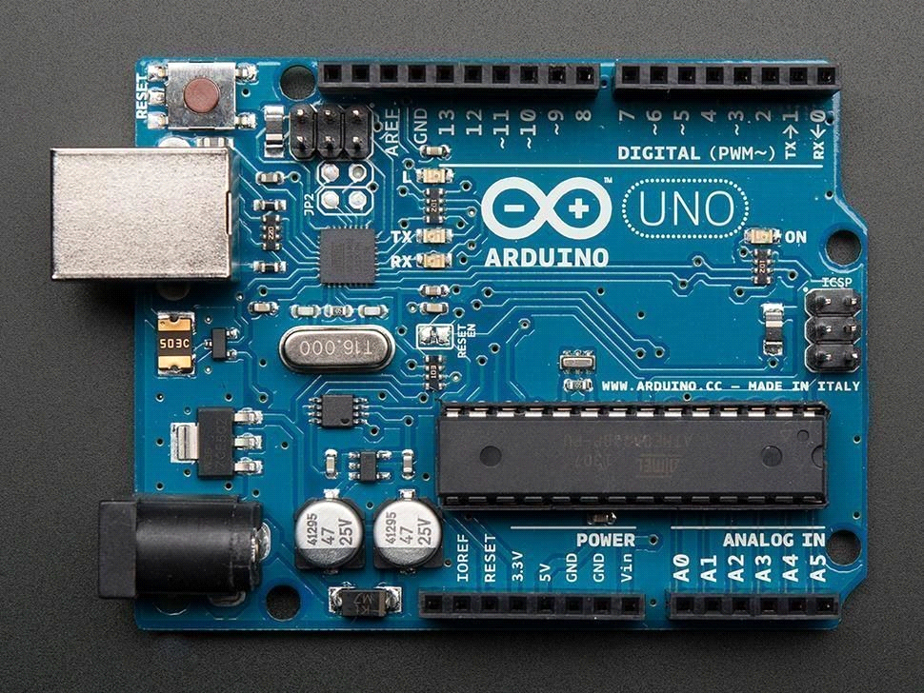

**• IR sensor**

An infrared sensor is an electronic device, that emits in order to sense some aspects of the surroundings. An IR sensor can measure the heat of an object as well as detects the motion.These types of sensors measures only infrared radiation, rather than emitting it that is called as a passive IR sensor.

**• Servo motor**

A closed loop system uses the feedback signal to adjust the speed and direction of the motor to achieve the desired result. RC servo motor works on the same principal. It contains a small DC motor connected to the output shaft through the gears. You can control the servo motor by sending a series of pulses to the signal line. A conventional analog servo motor expects to receive a pulse roughly every 20 milliseconds (i.e., signal should be 50Hz).

**• Breadboard**

Breadboard is an essential tool for all electronics engineer and maker.

**• Jumper wires**

Jumper wires are used for making connections between items on your breadboard and your Arduino’s header pins. Use them to wire up all your circuits!

**• LCD display**

There's also a display contrast pin (Vo), power supply pins (+5V and GND) and LED Backlight (Bklt+ and BKlt-) pins that you can use to power the LCD, control the display contrast, and turn on and off the LED backlight, respectively.

**• I2C module**

I2C Module has an inbuilt PCF8574 I2C chip that converts I2C serial data to parallel data for the LCD display. These modules are currently supplied with a default I2C address of either 0x27 or 0x3F. To determine which version, you have checked the black I2C adaptor board on the underside of the module.

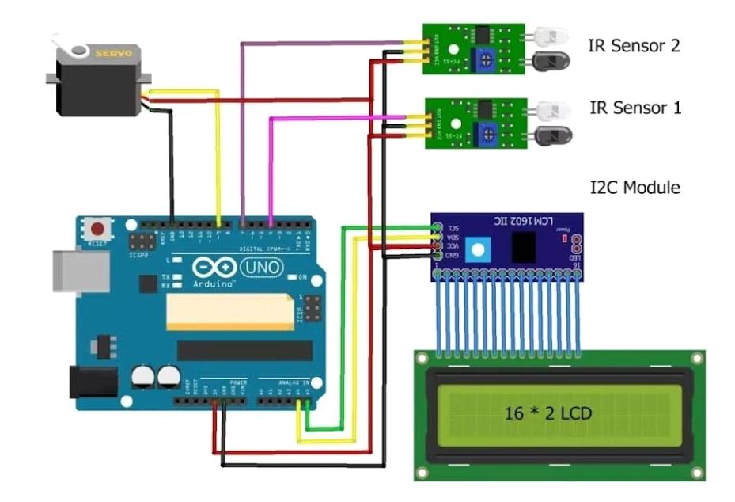

BLOCK DIAGRAM AND DESCRIPTION

**Project flow:**

* Collection of required components for project
* Planned the structural representation
* Connecting the sensors and testing them
* Programming the Arduino UNO with IDE Software

This smart parking system project consists of Arduino, five IR sensors, one servo motor, and one LCD display. Where the Arduino is the main microcontroller that controls the whole system. Two IR sensors are used at the entry and exit gates to detect vehicle entry and exit in the parking area. And other three IR sensors are used to detect the parking slot availability. The servo motor is placed at the entry and exit gate that is used to open and close the gates. Also, an LCD display is placed at the entrance, which is used to show the availability of parking slots in the parking area.

When a vehicle arrives at the gate of the parking area, the display continuously shows the number of empty slots. If there have any empty slots then the system opens the entry gate by the servo motor. After entering the car into the parking area, when it will occupy a slot, then the display shows this slot is full.

If there is no empty parking slot then the system displays all slots are full and does not open the gate.

**Block Diagram of Smart Parking System Project**

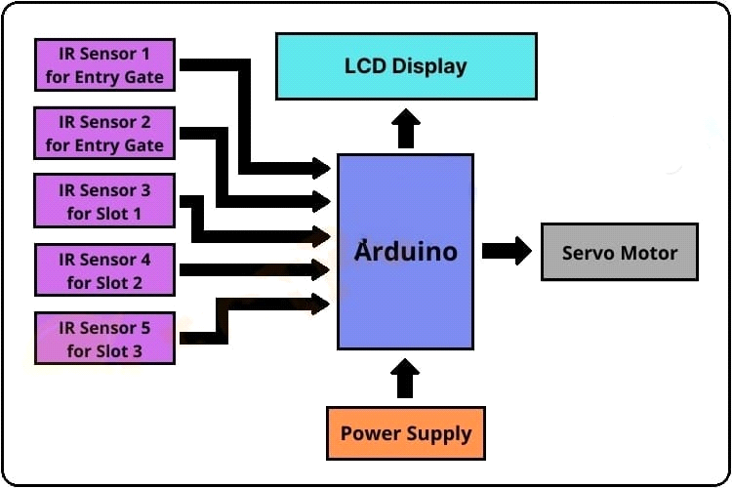

Results:

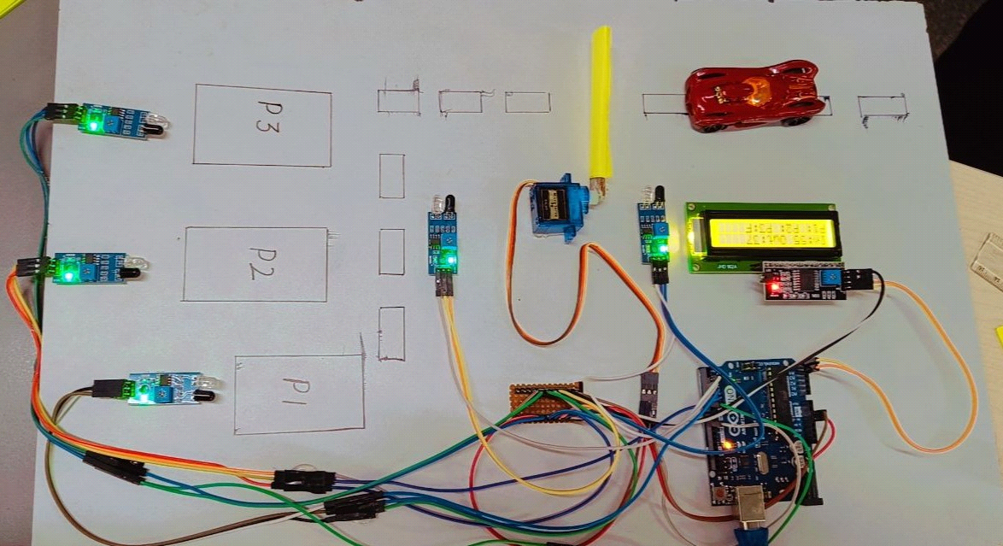

International Journal of Computer Applications (0975 – 8887) Volume 169 – No.1, July 2017 13 Smart Car Parking System using Arduino UNO Suvarna Nandyal, PhD Prof & H.O.D Dept Of Computer Science & Engineering PDA College of Engineering Gulbarga, India Sabiya Sultana Student Computer Science & Engineering Department PDA College of Engineering Gulbarga, India Sadaf Anjum Student Computer Science & Engineering Department PDA College of Engineering Gulbarga, India ABSTRACT In the early times the concept of smart cities have gained great popularity. The proposed Smart Parking system consists of an on-site deployment of an IOT module that is used to monitor and signalize the state of availability of single parking space. This paper introduce an IOT based coordinated framework for efficient and easy way of parking the vehicles by checking the availability of slots. The proposed Smart Parking framework comprises of an IOT module that is utilized to screen and signalize the condition of accessibility of single parking spot. The paper additionally depicts an abnormal state perspective of the framework engineering. Towards the end, the paper examines the working of the framework in type of an utilization case that demonstrates the rightness of the proposed show. The Ultrasonic Range Detection Sensor is utilized with Arduino to indicate the empty slot .By measuring the distance using ultrasonic sensor drivers are able to find the empty slot in parking to park the car and help the driver to find the slot easily and reduce the searching time.As the parking place is found to be empty it is detected using ultrasonic sensors which report it further. We achieved this by programming the sensors and Arduino. Keywords Smart Car Parking, IOT, Ardunio Uno, Ultrasonic Sensor. 1. introduction At the point when IoT is increased with sensors and actuators, the innovation turns into an occurrence of the more broad class of digital physical frameworks, which likewise incorporates advances. For Example, keen networks, virtual power plants, brilliant homes, astute transportation and shrewd urban communities. Among the difficulties that confront in everyday life one of most unavoidable test is parking the car wherever people go. As our need expands our setting out increments however because of extreme increment in utilization of vehicles and increment in populace this project confront the intense assignment of parking car especially amid busiest hours of the day.

Challenges Faced:

* The IR sensor can malfunction in closed areas.
* It can’t detect the hidden objects.
* The range of IR sensor is less, it only can measure up to 2-5cm.
* The connection of the sensor to the circuit without failure of the circuit.
* Consumption of battery.

Conclusion:

Our project detects the empty slots and helps the drivers to find parking space in unfamiliar city. The average waiting time of users for parking their vehicles is effectively reduced in this system. The optimal solution is provided by the proposed system, where most of the vehicles find a free parking space successfully. Our preliminary test results show that the performance of the Arduino UNO based system can effectively satisfy the needs and requirements of existing car parking hassles thereby minimizing the time consumed to find vacant parking lot and real time information rendering. This smart parking system provides better performance, low cost and efficient large scale parking system. When car enters the parking area, the driver will park the car in the nearest empty slot when slot is occupied the LED light glows and when slot are empty LED lights are turned off, indicating that the parking slot is empty to be occupied. It also eliminates unnecessary travelling of vehicles across the filled parking slots in a city.

**FUTURE ENHANCEMENT:**

In future works, this framework can be enhanced by including different applications, For Example, internet booking by utilizing GSM. The driver or client can book their parking area at home or while in transit to the shopping center. This can diminish the season of the client to seeking the empty parking area. As a further review, distinctive sensor frameworks can be added to enhance this framework to distinguish the question and guide the driver or clients speediest. We will attempt to decrease the mechanical structure and attempt to make it ecofriendly.